**Classroom Activity: Write a code for comparison operators in MongoDB collection.**

**Code: Write code for comparison operator equal ($eq) in collection.**

FoodDelivery> db.vendors.find({ "rating": { $eq: 4.7 } })

**OUTPUT:**

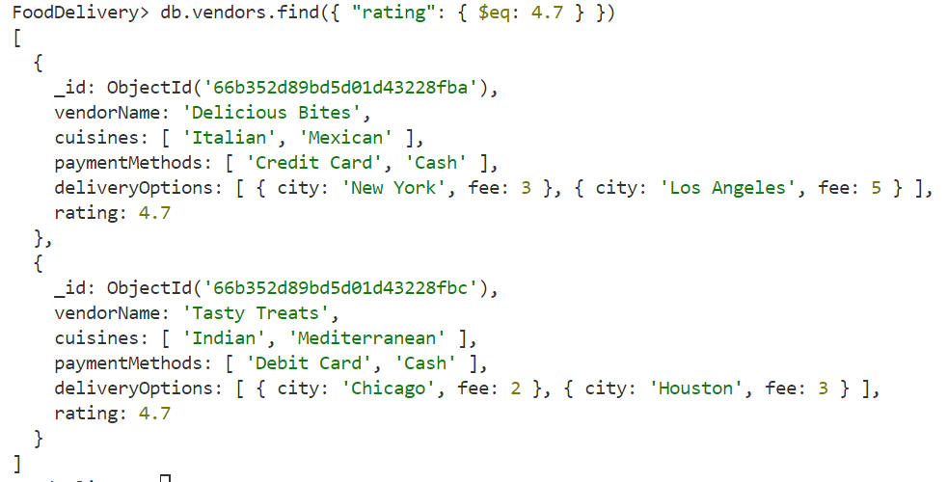

**Code: Write code for comparison operator not equal ($ne) in collection.**

FoodDelivery> db.vendors.find({ "rating": { $ne: 4.7 } })

**OUTPUT:**

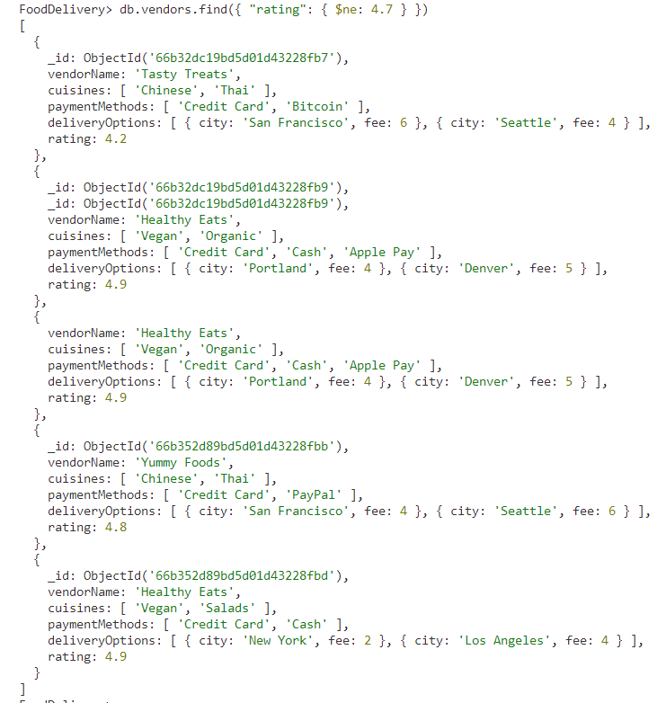

**Code: Write code for comparison operator less than ($lt) in collection.**

FoodDelivery> // Find all documents where the rating is less than 4.7

FoodDelivery> db.vendors.find({ "rating": { $lt: 4.7 } })

**OUTPUT:**

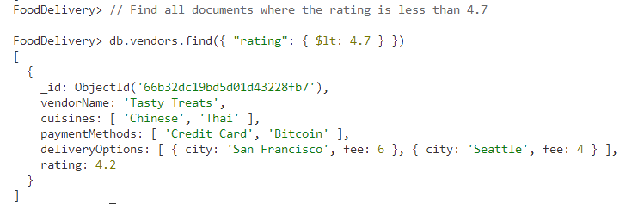

**Code: Write code for comparison operator greater than ($gt) in collection.**

FoodDelivery> // Find all documents where the rating is greater than 4.7

FoodDelivery> db.vendors.find({ "rating": { $gt: 4.7 } })

**OUTPUT:**

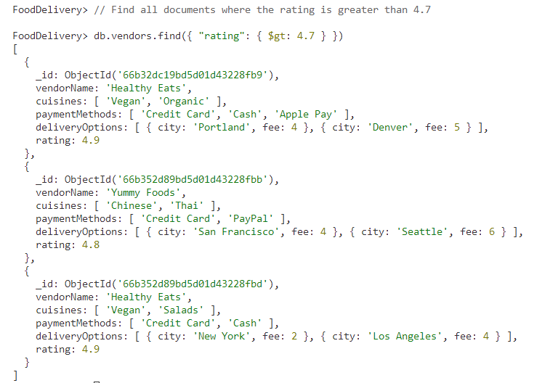

**Code: Write code for comparison operator less than or equal to ($lte) in collection.**

FoodDelivery> // Find all documents where the rating is less than or equal to 4.7

FoodDelivery> db.vendors.find({ "rating": { $lte: 4.7 } })

**OUTPUT:**

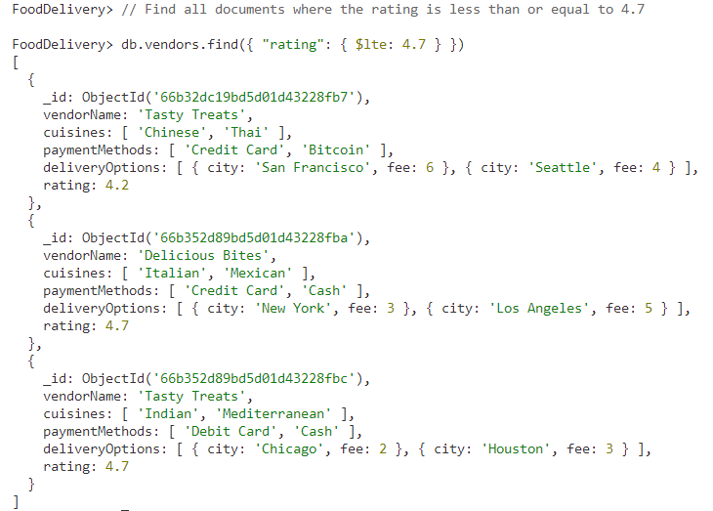

**Code: Write code for comparison operator greater than or equal to ($gte) in collection.**

|  |
| --- |
| FoodDelivery> // Find all documents where the rating is greater than or equal to 4.7  FoodDelivery> db.vendors.find({ "rating": { $gte: 4.7 } }) |

**OUTPUT:**

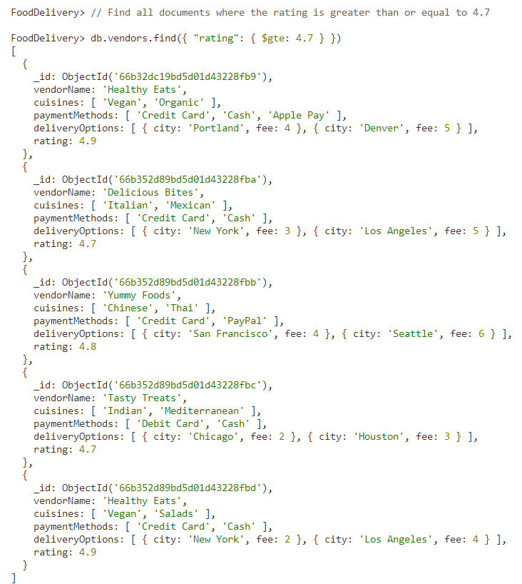

**Code: Write code for comparison operator in ($in) in collection.**

FoodDelivery> // Find all documents where the vendorName is in the specified array

FoodDelivery> db.vendors.find({ "vendorName": { $in: ["Delicious Bites", "Healthy Eats"] } })

**OUTPUT:**

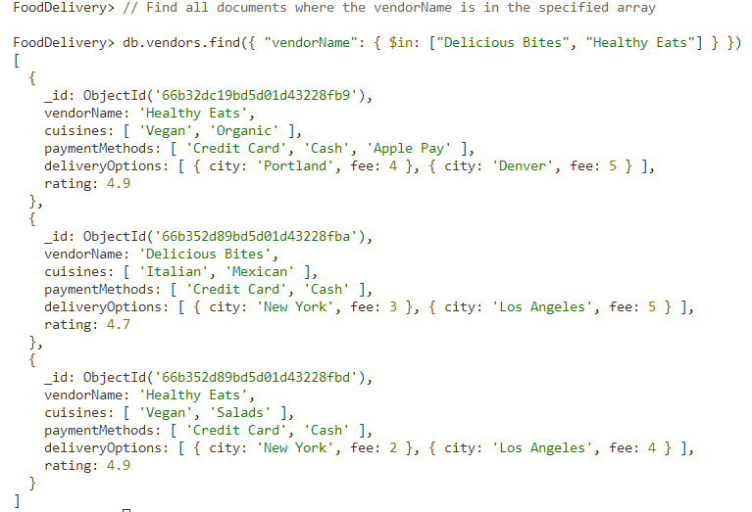

**Code: Write code for comparison operator not in ($nin) in collection.**

FoodDelivery> // Find all documents where the cuisines field does not contain "Italian" or "Chinese"

FoodDelivery> db.vendors.find({ "cuisines": { $nin: ["Italian", "Chinese"] } })

**OUTPUT:**

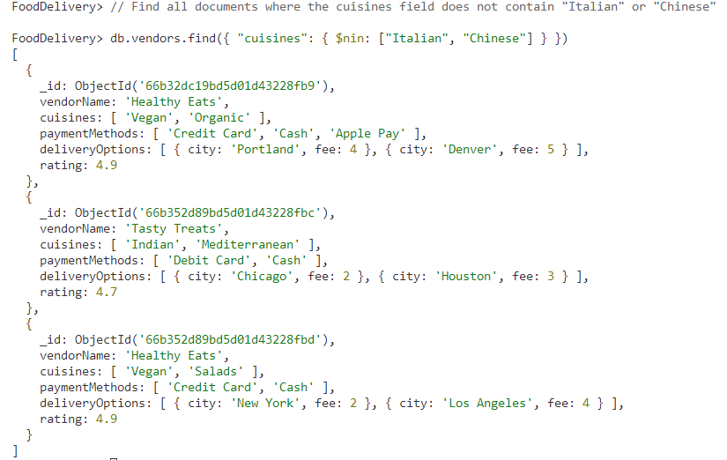

**Execution Steps:**

1. Install MongoDB compass and MongoDB shell
2. Create a new connection in MongoDB Compass
3. Create a new Database eg.)Food Delivery
4. Go to Visual Studio Code
5. Install the MongoDB for VS code extension
6. Click on the MongoDB icon on the navigation pane
7. Right-click on the localhost:27017 connection
8. Select Launch MongoDB shell
9. Finally execute the above code.